Maksat Mametjumayev

2022-10-14

***Write- Up1***

This is sample analysis of dataset that accompanied a <https://ourworldindata.org/corruption#evidence-from-surveys>, “The Perception of Corruption by Institution, World 2017” by Esteban Ortiz-Ospina and Max Roser that is published on 10 October, 2016 and revised on 10 May, 2019

The data is collected from Transparency International.

The database includes the following headings:

|  |  |
| --- | --- |
| Entity | text |
| Code | text |
| Year | int |
| Police | int |
| Legislature | int |
| Government_officials | int |
| Local_government_councillors | text |
| PrimeMinister_President | text |
| Tax_officials | text |
| Business_executives | int |
| Judges_and_magistrates | int |
| Religious_leaders | int |
| Traditional_leaders | text |

The database has 132phrases, for which there are entries for each of the above 13 attributes.

Findings:

1. I added the primary key as there was not any primary key assigned the attribute as Country Number: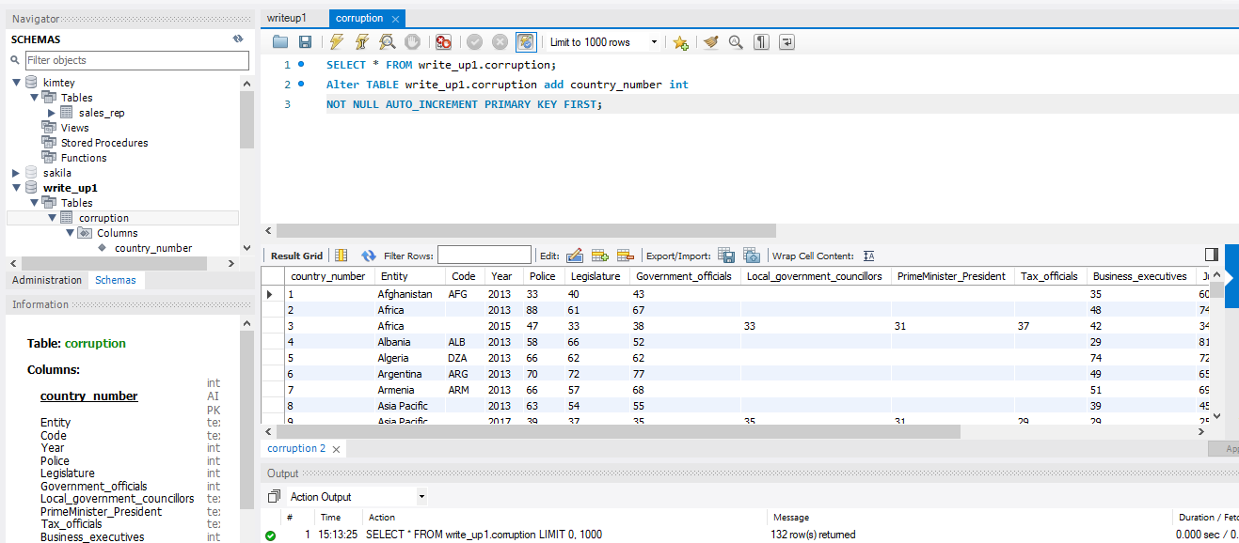
2. I dropped the unnecessary attributes which are not provide sufficient information: Code, Local_government_councillors, PrimeMinister_President, Tax_officials, and Traditional_leaders:

1. I ran queries of identifying the business_executives = 40.

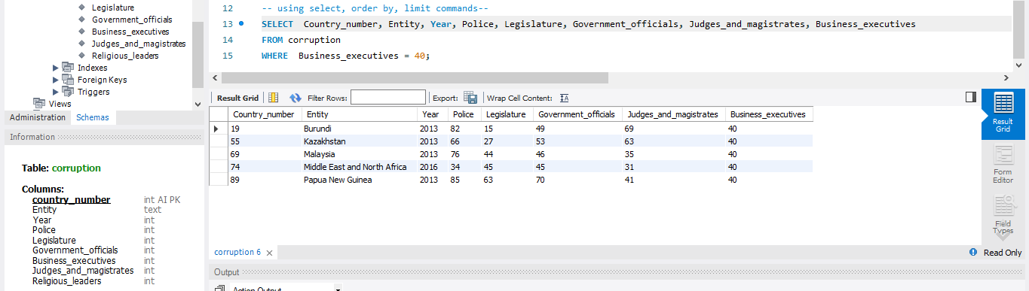

1. I ran queries of identifying the business_executives>=40.

1. I ran queries of identifying the business_excutives between 40 and 70.

1. I ran queries of identifying the year 2013 and 2017 and ordering by descending.

1. I ran queries of liming the phrases to 50.

1. I ran queries of identifying the entity=’Turkey’.

1. I ran queries of identifying the entity from A to Z.

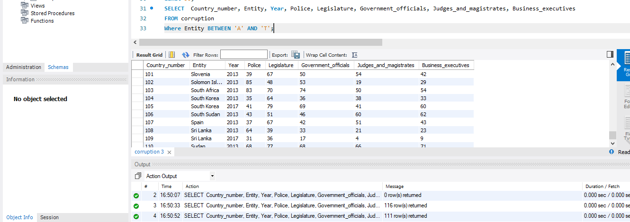

1. I ran queries of identifying of Government_official selects only 40 and 70.

